Below are designs for group project Learnado Application

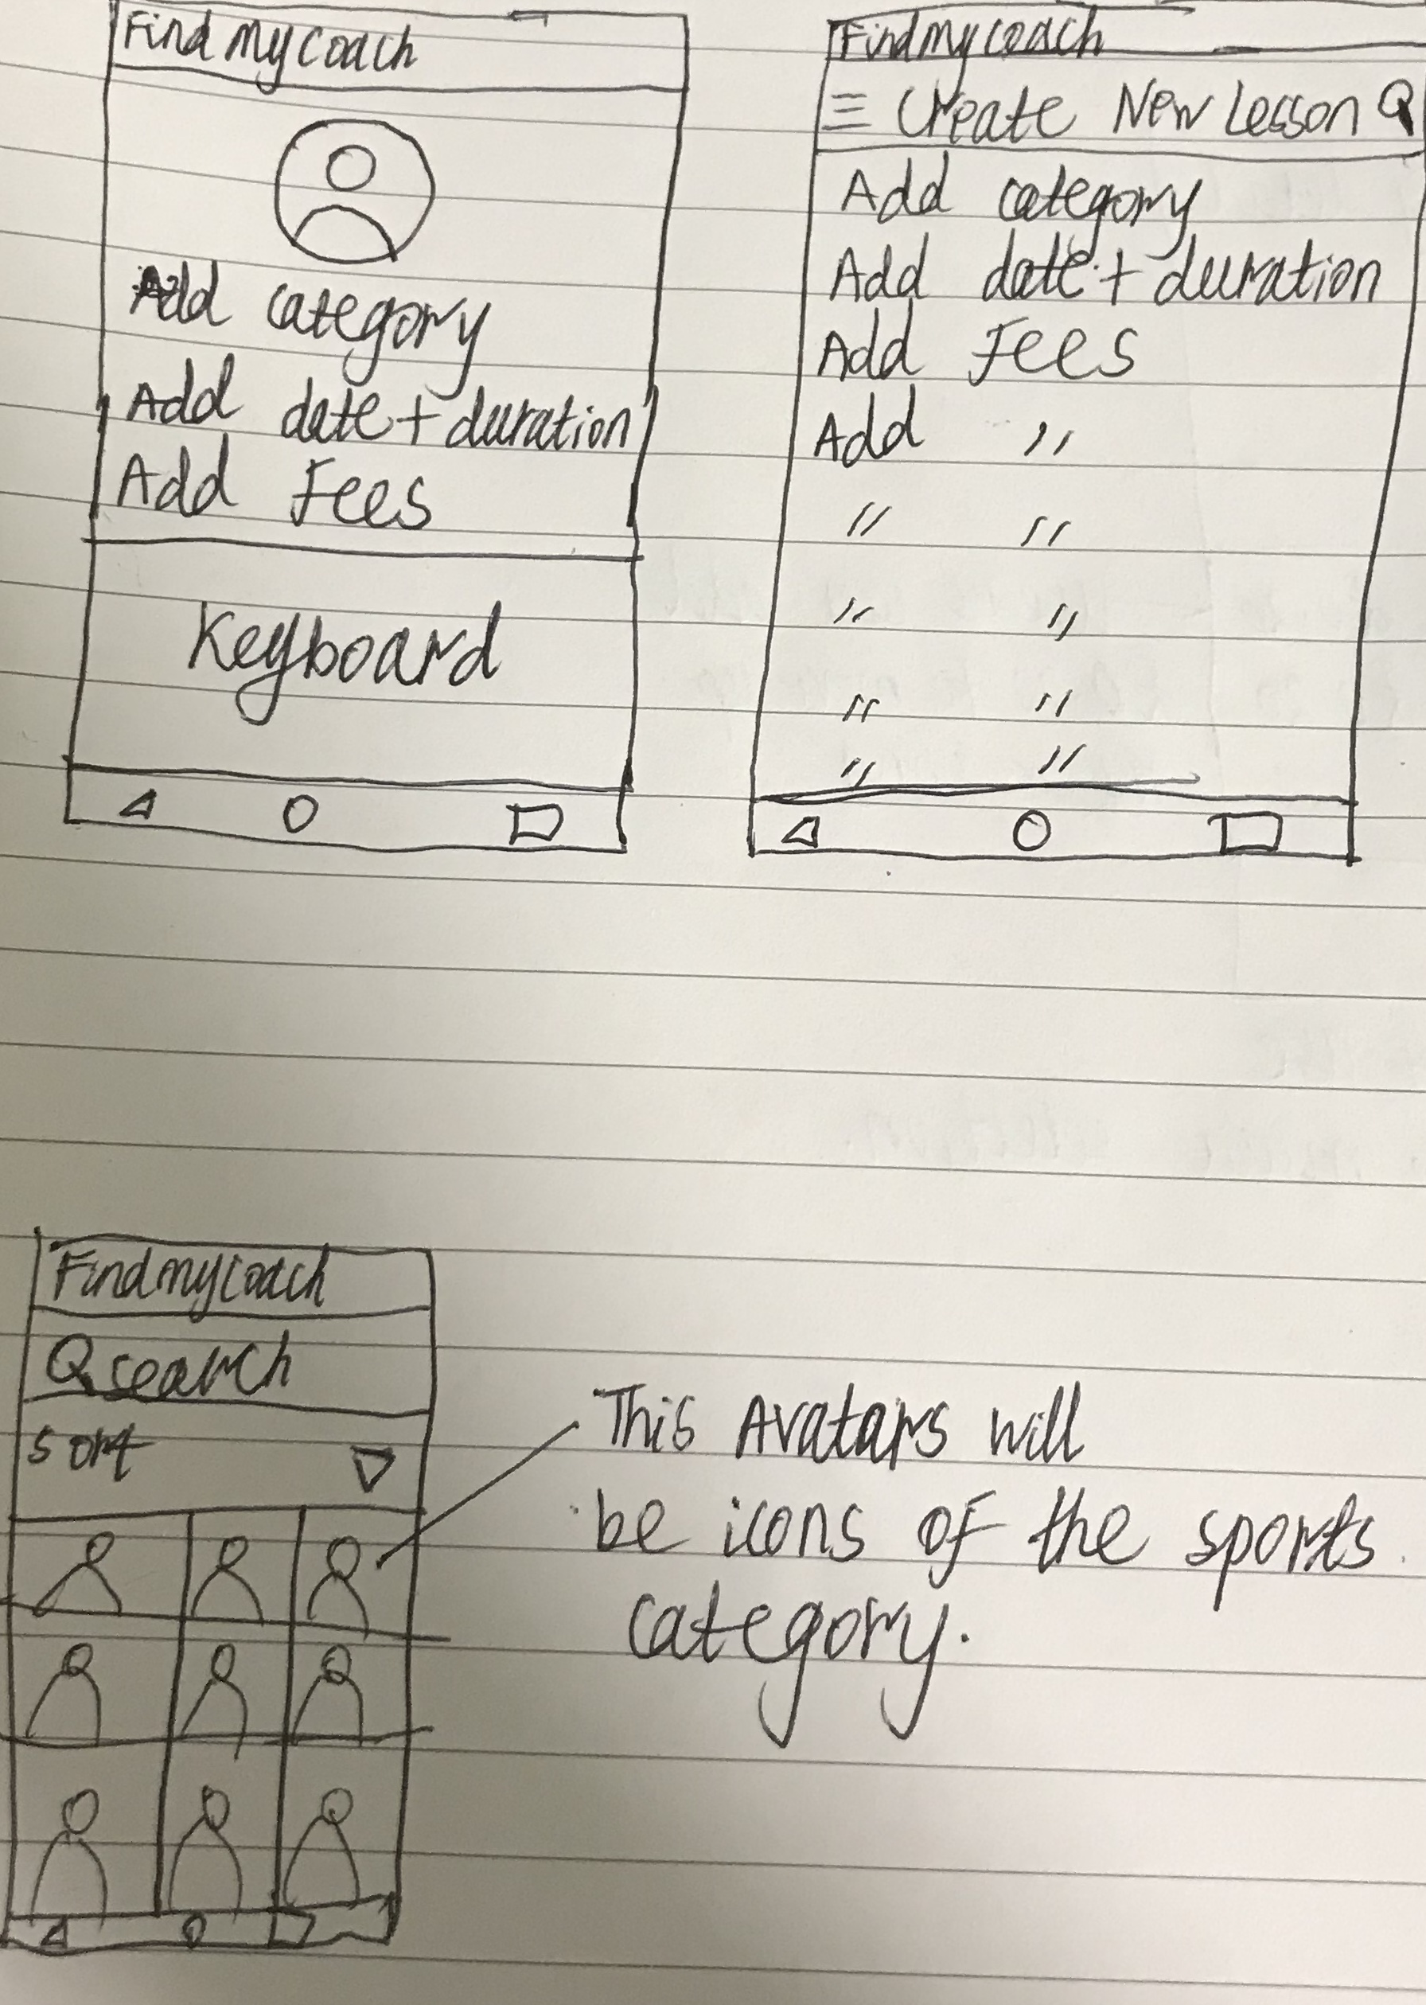Low-fidelity Prototypes



High-fidelity prototypes

